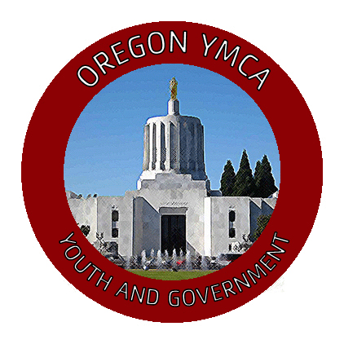
For Office use only:
Measure Number:
Committee:
Page Number: 1 of

Sponsors:
School/YMCA:
Relating to:
(A BILL FOR AN ACT)
- BE IT ENACTED BY THE PEOPLE OF THE STATE OF OREGON:
- SECTION ONE:

